TCoE TEST REPORT

Product Name | Altbank Bills Payment CORALPAY and Modification of Limit on Airtime
Pre-master PR Link | PR_link_to_Production from pre-master branch for implementers
Version Number | BuildVersion_Number
Cycle Number | 1
Test URL | http://altbank-admin-frontend-qa.sterlingapps.p.azurewebsites.net/
Workitem/Repo URL | https://dev.azure.com/SterlingAppsDevOps/AltBank/_workitems/edit/15144
General Description | Outlines the features and deployment details for Altbank Bills Payment CORALPAY and Modification of Limit on Airtime sent to the TCoE for testing.

- Certificate Summary
Is this build certified for deployment? Yes No

- Results Analysis
Total Number of Test Cases | 84
Passed Test Cases | 72
Failed Test Cases | 12
Un-executed Test Cases | 0
Suspended Test Cases | 0
Modification-Requiring Test Cases | 0
Automation-to-Manual Tests Ratio | 01:00
Click Here for details of test cases and results.
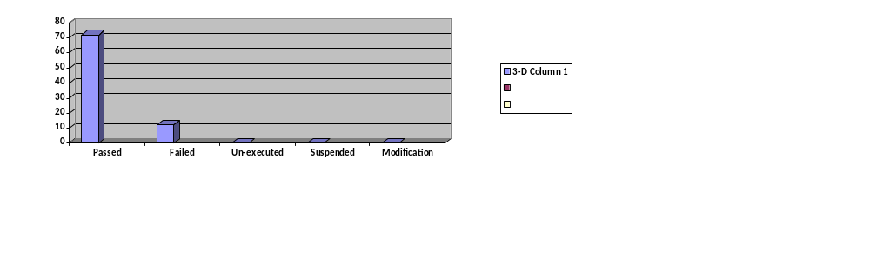

- BRD/SWR/ITR FEATURE STATUS IN THIS BUILD
S/N | Feature | Description | Implemented? | Functional?
1 |  | Verify that user can download the altbank mobile successfully | Yes No | Yes No
 |  | Verify that the Register or Signup button is visible on display | Yes No | Yes No
 | ONBOARDING | Verify that the the Signup button  is active | Yes No | Yes No
 |  | Verify that User gets a notification asking If they have a SAF account  Do you have a SAF account  -Yes  -No | Yes No | Yes No
 |  | Verify that user is redirected to the Registration page clicking on "Yes" | Yes No | Yes No
 |  | Verify that user can input information as:  -Account Number  -BVN | Yes No | Yes No
 |  | Verify that user receives OTP notification | Yes No | Yes No
 |  | Verify that system grants user access with the correct OTP | Yes No | Yes No
 |  | Verify that system denies user access with the wrong OTP | Yes No | Yes No
 |  | Verify that the user is welcome into the App | Yes No | Yes No
 |  | Verify that user is redirected to the authentication Page | Yes No | Yes No
 |  | Verify that user can create Password | Yes No | Yes No
 |  | Verify that user can create transaction PIN | Yes No | Yes No
 |  | Verify that user can authenticate successfully | Yes No | Yes No
 |  | Verify that user can create Security questions successfully | Yes No | Yes No
 | FREE TRANSFERS CHARGES | Verify that user can make intra-bank transfer within now and EOY without charges | Yes No | Yes No
 |  | Verify that user cannot make intrabank transfer after EOY without charges | Yes No | Yes No
 |  | Verify that user can make interbank transfer between now and EOY without charges | Yes No | Yes No
 |  | Verify that user cannot make interbank transfer after EOY without charges | Yes No | Yes No
 |  | Verify that user can make a whole amount transfer without charges | Yes No | Yes No
 |  | Verify that user can make decimal amount transfer without charges | Yes No | Yes No
 |  | Verify that Interbank transfers are reflected on the balance on altbank app | Yes No | Yes No
 |  | Verify that Intrabank transfers are reflected on the balance on altbank app | Yes No | Yes No
 |  | Verify that business can switch on or off the free transfer charges. | Yes No | Yes No
 |  | Verify that all transfers or transcation reflects on the Core or Altbank DB | Yes No | Yes No
 | BILL PAYMENTS | Verify that user can make bill payments on all platform | Yes No | Yes No
 |  | Verify that user can select a biller category on all platform | Yes No | Yes No
 |  | Verify that user can make bill payments within limit of N50,000k per day | Yes No | Yes No
 |  | Verify that user cannot make bill payments above limit of N50,000.50k per day | Yes No | Yes No
 |  | Verify that user can select a biller item successfully on all item | Yes No | Yes No
 |  | Verify that Shows all biller category with equivalent amount,  categories but not limited to the underlisted  · Utilities  Under utilities: AEDC – 1%  KEDCO – 1%  DSTV – 1.40% | Yes No | Yes No
 |  | When user selects any of the above billers, system  should perform the following:  Permit transaction  Pass the entries below:  DEBIT Customer A/c: 050******* ------ (Transaction  Value)  CREDIT Coral Pay payable acct: To be opened ---  -  DEBIT Customer A/c: 050******* N100 ------------(Bill  Payment Fee)  CREDIT convenience FEE Account N100  (collection account): To be opened (Bill Payment  Fee) | Yes No | Yes No
 |  | Verrify that If If the transaction fails, system should pass the  following entry:  DEBIT Coral Pay payable acct: To be opened -----  ()  CREDIT Customer A/c: 050*******  DEBIT convenience FEE Account N100 (collection  account): To be opened (Bill Payment Fee)  CREDIT Customer A/c: 050******* ------------ N100 (Bill  Payment FeeIf the transaction fails, system should pass the  following entry:  DEBIT Coral Pay payable acct: To be opened -----  ()  CREDIT Customer A/c: 050*******  DEBIT convenience FEE Account N100 (collection  account): To be opened (Bill Payment Fee)  CREDIT Customer A/c: 050******* ------------ N100 (Bill  Payment Fee) | Yes No | Yes No
 |  | Verify that at Settlement At settlement:  Debit convenience fee Acct N100  System Realtime  Standard Work Request (SWR)  Internal Use  Page 3 of 5  Credit Income Acct (with less 1% or 1.40% of N100)  Depending on selected biller.  Credit Coral Pay Settlement Acct 1% OR 1.40% of  N100 (Depending on the selected biller)  DEBIT Coral Pay payable acct  Credit Coral Pay Settlement Acct  NOTE: This account warehouses the convenience  fee on every bill payment prior to sharing ratio  agreed by the bank and coral pay | Yes No | Yes No
 |  | Verify that user can make a bill payment within limit for airtime and data(N20,000) | Yes No | Yes No
 |  | Verify that user cannot make a bill payment above limit (N20,000.50k) for airtime and data | Yes No | Yes No
 |  | Verify that user gets a pop-up message for bill payment above limit(20k) with message stating:  -Dear customer, you have exceeded the daily  limit for airtime/data. | Yes No | Yes No
 | LIMITS | Check that customers cannot make single payments at full  integer values beyond Default Per Transaction Limits for the  product under test | Yes No | Yes No
 |  | Check that customers cannot make single payments at .01  decimal values beyond Default Per Transaction Limits for the  product under test | Yes No | Yes No
 |  | Check that customers cannot make several individual payments  at full integer values beyond Default Daily Cumulative Transaction  Limits for the product under test | Yes No | Yes No
 |  | Check that customers cannot make several individual payments  at .01 decimal values beyond Default Daily Cumulative  Transaction Limits for the product under test | Yes No | Yes No
 |  | Check that customers can request and complete transaction limit  upgrade requests | Yes No | Yes No
 |  | Check that indemnity terms are presented to customers on limit  upgrade requests | Yes No | Yes No
 |  | Check that customers are required to consent to the limit  upgrade indemnity terms presented | Yes No | Yes No
 |  | Check that limit upgrade request is affected successfully after  indemnity terms are consented to | Yes No | Yes No
 |  | Check that customer can pass transactions to the tune of the limit  upgrade requested successfully | Yes No | Yes No
 |  | Verify that Admin can view all limit transactions from customers | Yes No | Yes No
2 | BALANCE CHECK | Check that customers cannot complete transactions successfully  for full integer amount greater than the Available Balance on their  account | Yes No | Yes No
 |  | Check that customers cannot complete transactions successfully  for .01 decimal amount greater than their Available Balance on  their account | Yes No | Yes No

- EXCEPTIONS & OBSERVATIONS
Test Case ID(s) | Status Type | Description | SEVERITY | RISK ASSESSMENT
ID_in_testCase ALTBANKMOB_026- ALTBANKMOB_037 | Failed | Bills payments, airtime and data Limits | High | High

- COMMENTS
The test for the Altbank Free transfer and Bills payment CORALPAY has been completed successfully. However, please note that failed test cases 026-037 speaks to the bill payment, airtime and data limit as the activities will be validated on PILOT as agreed by the product owner herein undersigned.

This is certified ready for CAB review towards deployment.

- REVIEW AND APPROVAL
Action | Name | Staff ID | Signature | Date
Tested By | Ajibade Olusola | 006630 | 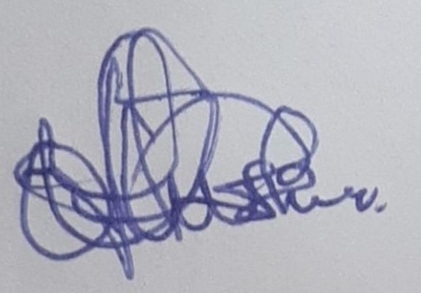 | 17-11-2022
Product Owner Concurrence | Chukwudumebi Oshunkeye
Unit Lead Approval | Francis Egbuchu
Head, TCoE | Abimbola Babalola
s

Security Notice: The information contained within this document is CONFIDENTIAL. Unauthorized disclosure is prohibited. Failure to observe Sterling Bank guidelines regarding proprietary information can result in disciplinary action, including dismissal, and can subject you and/or third parties to legal liability.

Handling Guidelines: (Tick all that apply)
Do not forward or copy data in part or full without explicit permission of Sterling Bank Plc
Limit access to individuals on Access List / Lock in a Drawer / Cabinet.
Password-protect when emailed outside Sterling Bank’s Network / Send password separately

